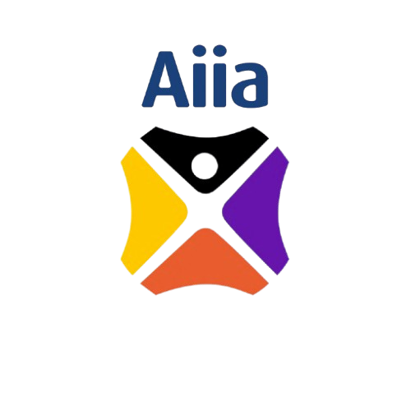 | Artificial Intelligence Initiative Africa  275 Hebert Chitepo Ave, Harare, Zimbabwe  +263 78 6434 998 admin@aiInitiativeafrica.com  www.aiinstituteafrica.com
Financial Proposal
Project Plan | Deliverables | Number  of Days | Assessments | Unit Price  per session | Cost
Training readiness assessment | 6 sessions | 3 days | 0 | $166.66 | $1000
Board Training | 3 sessions (2 physical, 1 online) | 2 1/2 days | 1 | $833.33 | $2500
Exco | 3 sessions (2 physical, 1 online) | 2 1/2 days | 1 | $833.33 | $2500
Management | 3 sessions (2 physical, 1 online) | 2 1/2 days | 1 | $833.33 | $2500
Support Functions (HR, Risk, Audit) | 3 sessions (2 physical, 1 online) | 2 1/2 days | 1 | $833.33 | $1300
Branches (Southern) | 3 sessions (2 physical, 1 online) | 2 1/2 days | 1 | $433.33 | $1300
Technical | 3 sessions (2 physical, 1 online) | 2 1/2 days | 1 | $433.33 | $1300
Branches (Northern) | 3 sessions (2 physical, 1 online) | 2 1/2 days | 1 | $433.33 | $1300
Total |  |  |  |  | $13 700

 | Artificial Intelligence Initiative Africa  275 Hebert Chitepo Ave, Harare, Zimbabwe  +263 78 6434 998 admin@aiInitiativeafrica.com  www.aiinstituteafrica.com
Procurement Reference Number: AFC10/2026
Subject of Procurement: Provision of Artificial Intelligence Training
Name of Consultant: Rubiem Intelligence & AI Institute Africa
Consultant's Reference Number:
Date of Financial Proposal: 18 May 2026
The total price of our proposal is: USD 15,100.00 (United States dollars fifteen thousand one hundred only).
We confirm that the rates quoted in our Financial Proposal are fixed and firm for the duration of the validity period and will not be subject to revision or variation or adjustment.
Financial Proposal Authorised By:
Signed | 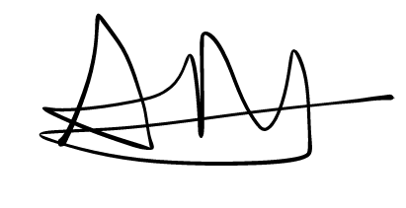 | Name: | Arthur Magaya
In capacity of: | CEO | Date: | 18/05/26
Duly authorised for and on behalf of:
Firm | Rubiem Intelligence
Address: | 75 Herbert Chitepo Avenue, Harare
Corporate Seal (where appropriate)

 | Artificial Intelligence Initiative Africa  275 Hebert Chitepo Ave, Harare, Zimbabwe  +263 78 6434 998 admin@aiInitiativeafrica.com  www.aiinstituteafrica.com
Summary of Costs
{Complete this form to summarise all the costs together from the breakdown of costs and submit it as part of your financial proposal.}
Item | Costs
 | [Indicate Currency]
Fees | $13 700
Reimbursable Costs | 0
VAT | $2 123.5 (15.5%)
Total Cost of  Financial Proposal¹ | $13 700

 | Artificial Intelligence Initiative Africa  275 Hebert Chitepo Ave, Harare, Zimbabwe  +263 78 6434 998 admin@aiInitiativeafrica.com  www.aiinstituteafrica.com
Currency of Costs: USD
FEES
Name and Position of Personnel | Input  Quantity | Unit  of  Input | Unit Rate | Total Price
Dr Martin Maduva | 5 | Sessions | $548 | $2 740
Dr Dennis Magaya | 5 | Sessions | $548 | $2 740
Dr Tendai Zengeni | 5 | Sessions | $548 | $2 740
Dr Gombiro | 5 | Sessions | $548 | $2 740
Mr Rupere | 5 | Sessions | $548 | $2 740
Sub Total: | 25 |  |  | USD 13 700
Financial Proposal Authorised By:
Signed |  | Name: | Arthur Magaya
In capacity of: | CEO | Date: | 18/05/26
Duly authorised for and on behalf of:
Firm | Rubiem Intelligence
Address: | 75 Herbert Chitepo Avenue, Harare
Corporate Seal (where appropriate)

